**Project Design Phase-II**

**Technology Stack (Architecture & Stack)**

|  |  |
| --- | --- |
| Date | 24 May 2023 |
| Team ID | PBL-NT-GP-10533-1682762877 |
| Project Name | Competitive analysis of leading travel aggregators |

**Technical Architecture:**

The Deliverable shall include the architectural diagram as below and the information as per the table1 & table 2

**Example: Order processing during pandemics for offline model**

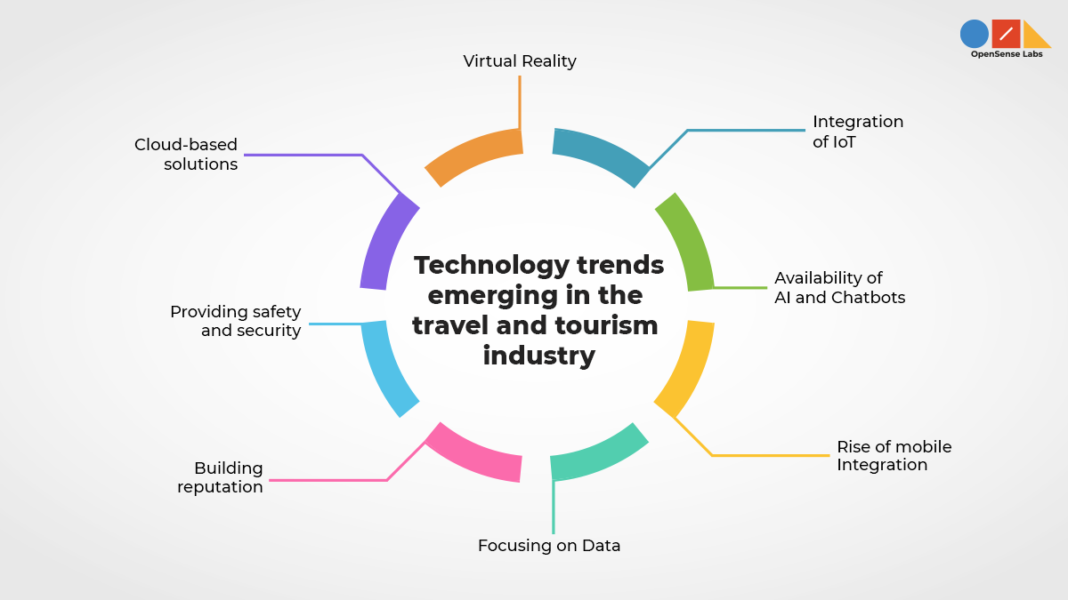

**Table-1 : Components & Technologies:**

|  |  |  |  |
| --- | --- | --- | --- |
| **S.No** | **Component** | **Description** | **Technology** |
|  | User Interface | User Interface (UI) design plays a crucial role in the success of travel aggregators, providing an intuitive and engaging experience for users such as homepage , booking process and user accounts. | HTML, CSS, JavaScript ,UI/UX Design tools , AJAX etc. |
|  | Application Logic-1 | Leading travel aggregators involves the core functionalities and processes that power the platform's operations | Java / Python , HTTPS , Django |
|  | Application Logic-2 | Leading travel aggregators focuses on additional functionalities and processes that enhance the user experience and provide added value | IBM Watson STT service |
|  | Application Logic-3 | Leading travel aggregators focuses on administrative and operational functionalities that enable efficient management of the platform and support business operations | IBM Watson Assistant |
|  | Database | Databases that are capable of handling large volumes of data and supporting complex search and retrieval operations | MySQL, NoSQL, etc. |
|  | Cloud Database | Databases that are capable of handling large volumes of data and supporting complex search and retrieval operations | Amazon aurora, NOSQL. |
|  | File Storage | File storage solutions to store and manage different types of files, such as images, documents, videos, and other multimedia content | IBM Block Storage or Other Storage Service or Local Filesystem |
|  | External API-1 | External API 1 for leading travel aggregators: Flight Search and Booking API | IBM Weather API, etc. |
|  | External API-2 | API enables travel aggregators to access and integrate hotel-related information from various hotel chains, online travel agencies (OTAs), and hotel wholesalers | Aadhar API, etc. |
|  | Machine Learning Model | Machine learning models play a crucial role in leading travel aggregators by powering various intelligent features and service such as recommendation system , fraud detection , NLP . | Object Recognition Model, etc. |
|  | Infrastructure (Server / Cloud) | Infrastructure to handle the high volume of data, user traffic, and complex functionalities involved in their operations. | Local, Cloud Foundry, Kubernetes, etc. |

**Reference:** [**https://developer.ibm.com/patterns/ai-powered-backend-system-for-order-processing-during-pandemics/**](https://developer.ibm.com/patterns/ai-powered-backend-system-for-order-processing-during-pandemics/)

| **S.No** | **Characteristics** | **Description** | **Technology** |
| --- | --- | --- | --- |
|  | Open-Source Frameworks | Leading travel aggregators often utilize a combination of open source frameworks and technologies to power their platforms such as  Django, React, Ruby, Laravel. | Linux operating system, Open stack |
|  | Security Implementations | Security is of paramount importance for leading travel aggregators, considering the sensitive user information, financial transactions, and potential threats they face. | Web application firewall, 2FA , Identity and Access Management |
|  | Scalable Architecture | They need to handle high volumes of traffic, accommodate growing user bases, and support increasing data processing requirements | Cloud computing platforms ,Distributed database. |
|  | Availability | High availability to ensure their platforms are accessible and functional for users at all times | PHP , JavaScript , GCP |
|  | Performance | Response time , search speed , caching. | PHP , JavaScript, Ruby . |

**References:**

[**https://c4model.com/**](https://c4model.com/)

[**https://developer.ibm.com/patterns/online-order-processing-system-during-pandemic/**](https://developer.ibm.com/patterns/online-order-processing-system-during-pandemic/)

[**https://www.ibm.com/cloud/architecture**](https://www.ibm.com/cloud/architecture)

[**https://aws.amazon.com/architecture**](https://aws.amazon.com/architecture)

[**https://medium.com/the-internal-startup/how-to-draw-useful-technical-architecture-diagrams-2d20c9fda90d**](https://medium.com/the-internal-startup/how-to-draw-useful-technical-architecture-diagrams-2d20c9fda90d)